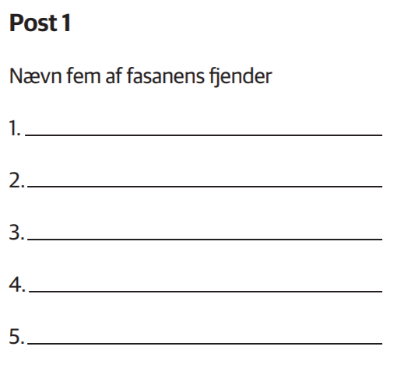

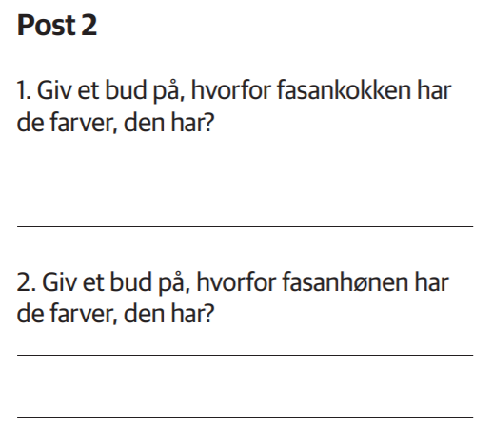

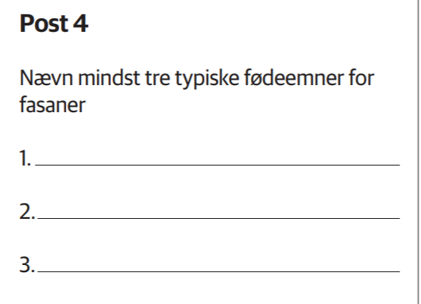

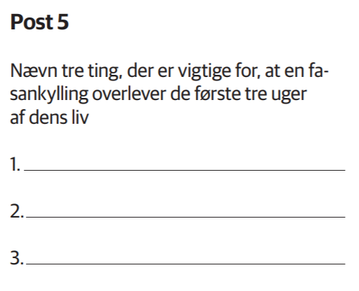

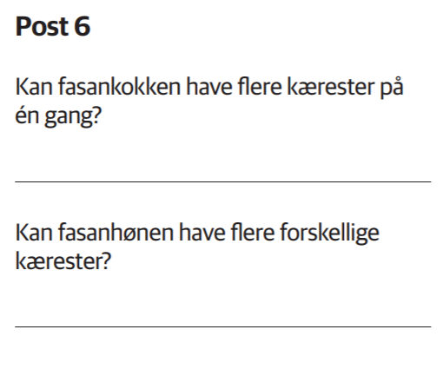

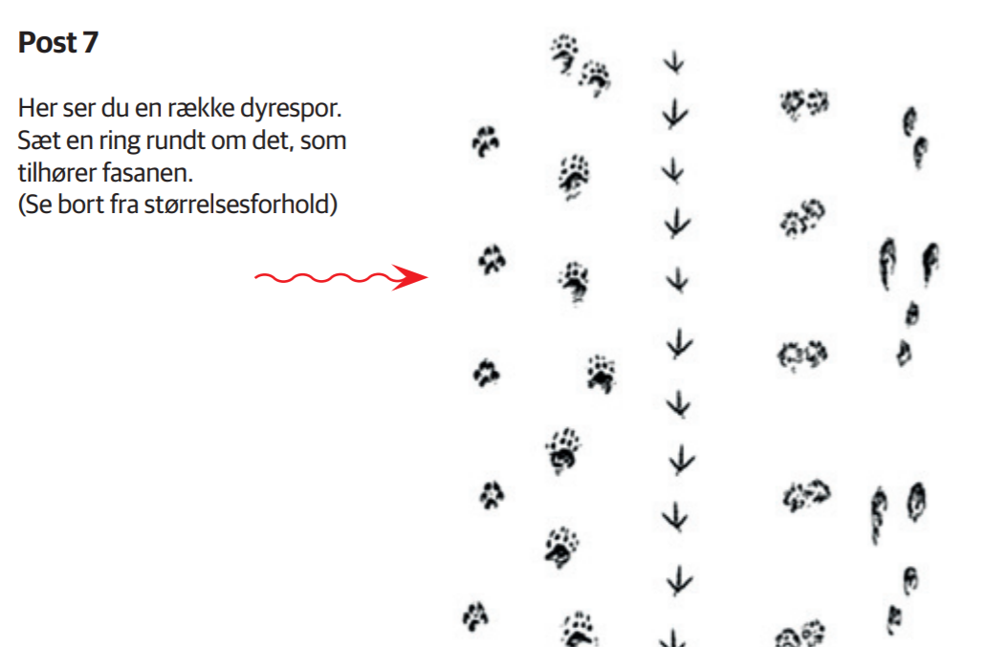
1 2 3 4 5

Fasanquiz 1
Navn:_________________________________
Post 1
Post 2
Post 3
Post 4
Post 5
Post 6 | Fasankok ja/nej  Fasanhøne ja/nej

Fasanquiz 2
Navn:_________________________________
Post 1
Post 2 | 1.  2.
Post 3
Post 4
Post 5
Post 6 | Fasankok ja/nej  Fasanhøne ja/nej

